**The Install**

Open the VirtualBox which is running on our machine with IP address of 172.16.10.201:1 with help of VNC viewer.

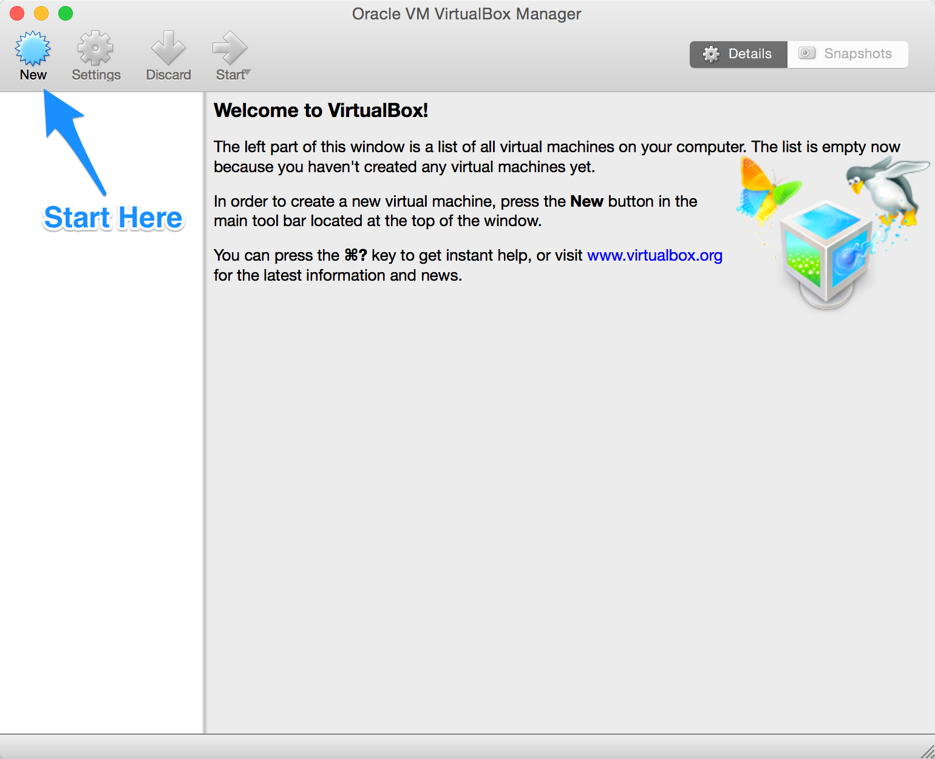

Name your VM anything you want, but make sure you choose Linux as the type and Red Hat (64-bit) as the version.

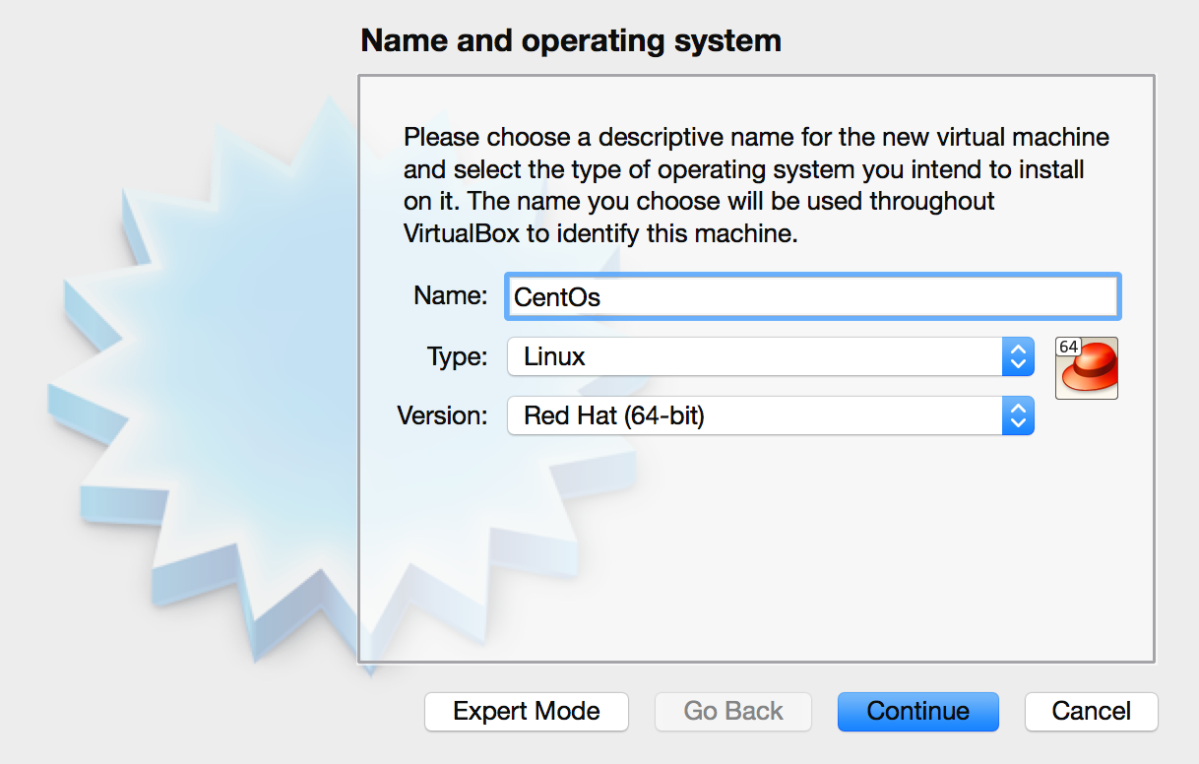

Next, choose the amount of memory you'd like to reserve for this VM. I usually just go with the suggested amount, which in this case is 768MB.

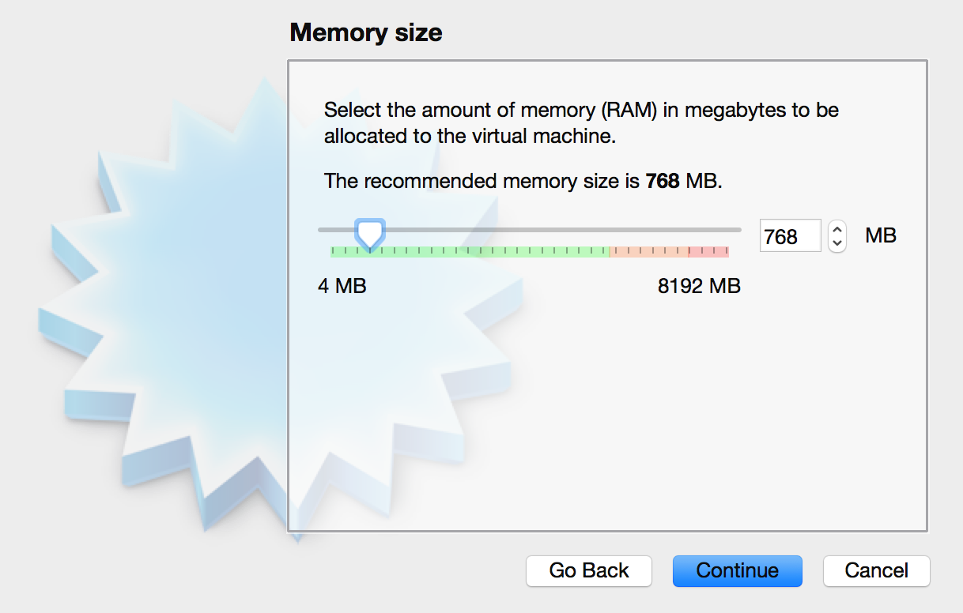

The next prompt will ask you to add a virtual hard disk. Go ahead and select Create a virtual hard disk now which should be the default.

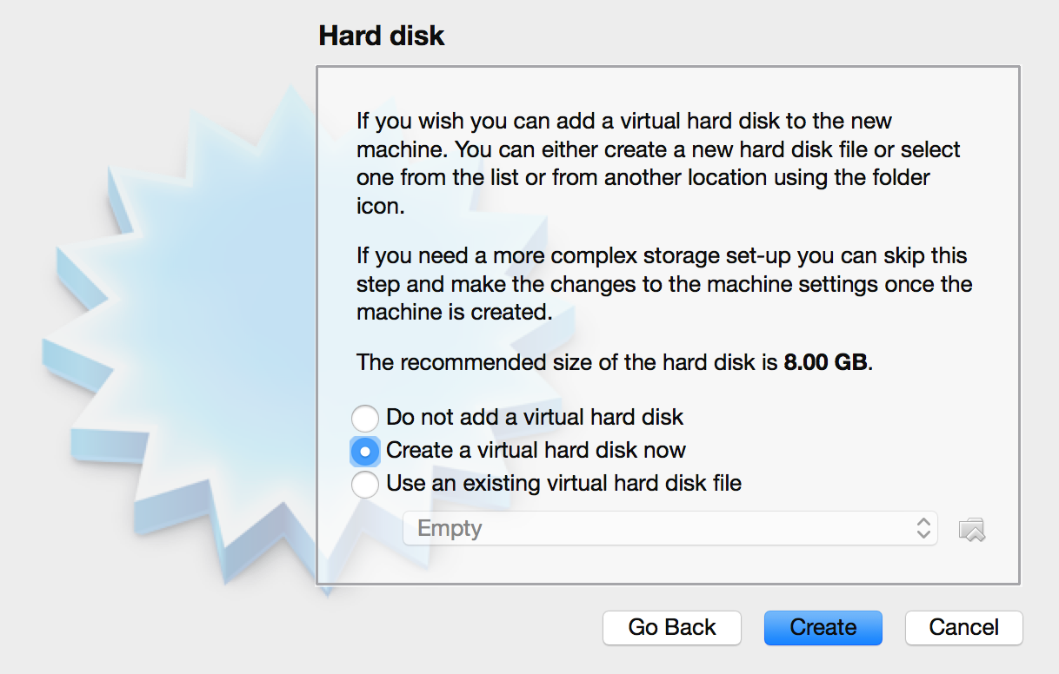

Next, you can select whichever type of VM hard disk type you'd like. I usually just select VDI.

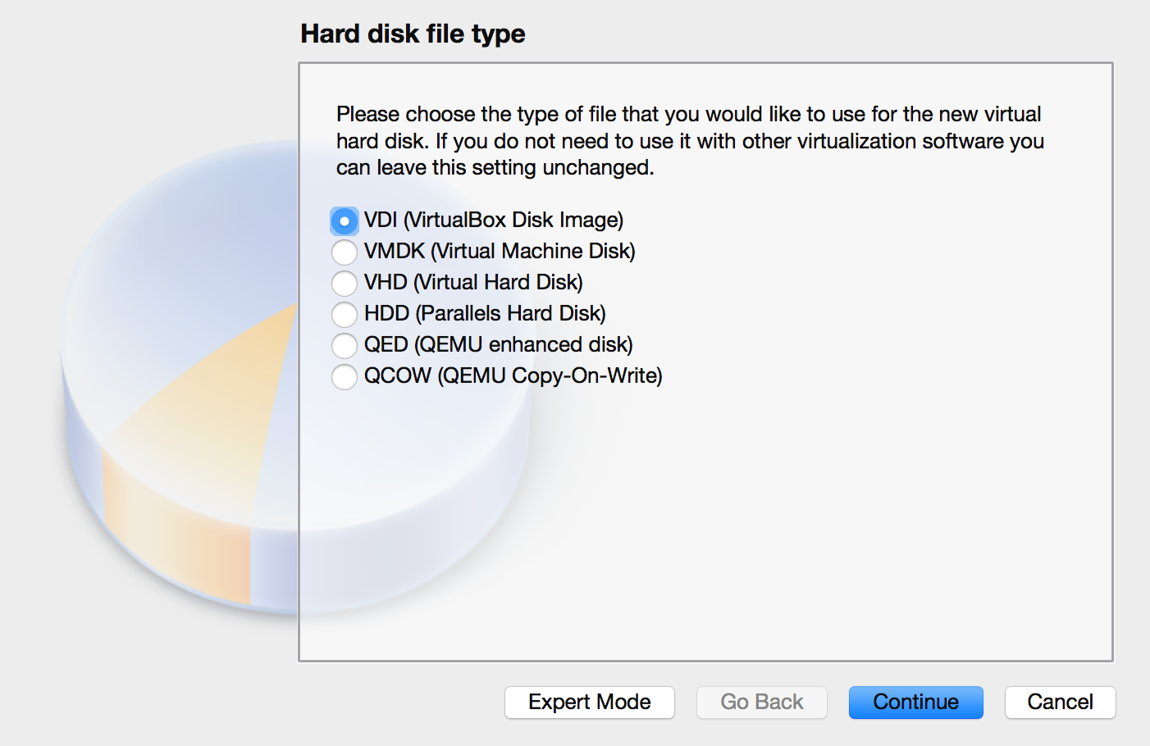

The next prompt will ask you if you would like dynamic storage or fixed storage. Select dynamic. Dynamic storage means that VirtualBox will only use the amount of space, on your real hard drive, that the VM needs until it reaches the maximum we allot. This will also allow us to add more to the VM later if we need it.

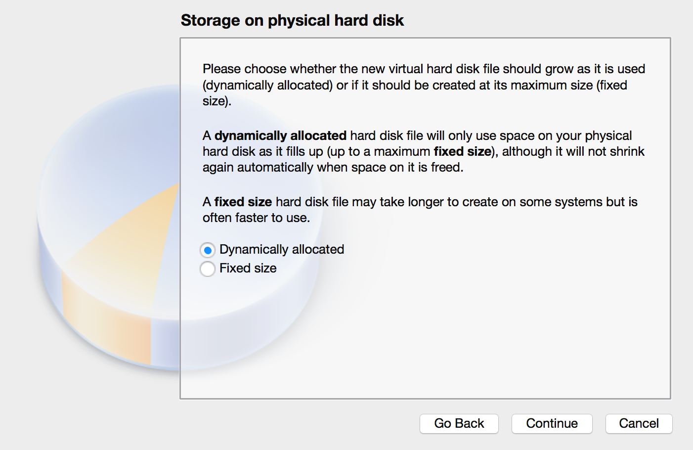

The next step is to actually allot the amount of hard disk space for the VM. 8.00GB will be more than plenty to start off. Go ahead and press the Create button to finish up this part of the process.

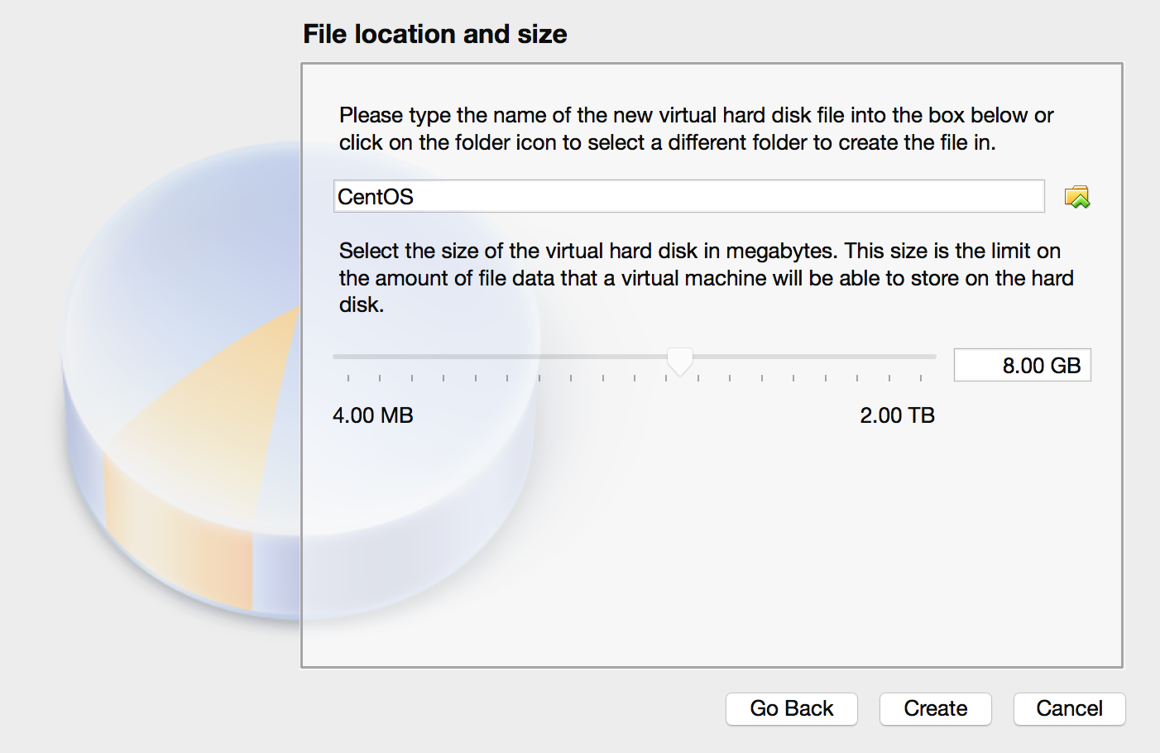

Now that we've setup the setup, it's time to install the VM. Your VirtualBox window should now contain a VM that is powered off.

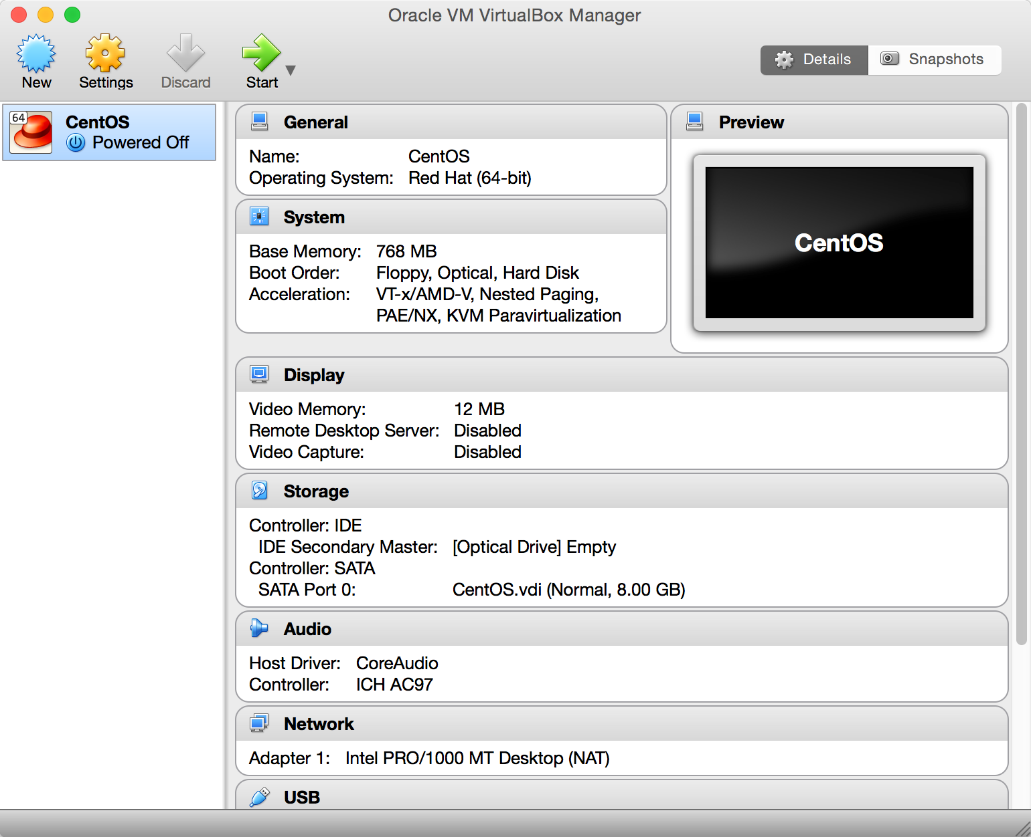

Find your newly created VM space and double click on it to start it up. You will be prompted to point the manager to the iso we downloaded earlier. Locate the file and click start.

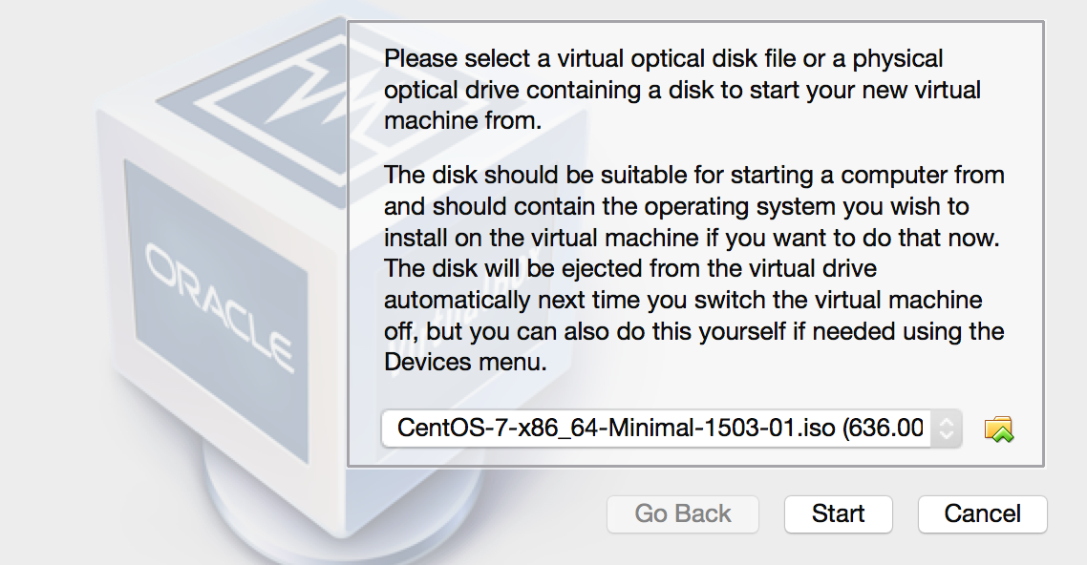

After you click start, VirtualBox will start the iso and you will be prompted to select an install mode. I usually just select Install CentOS 7, but it defaults to Test this media & install CentOS 7.

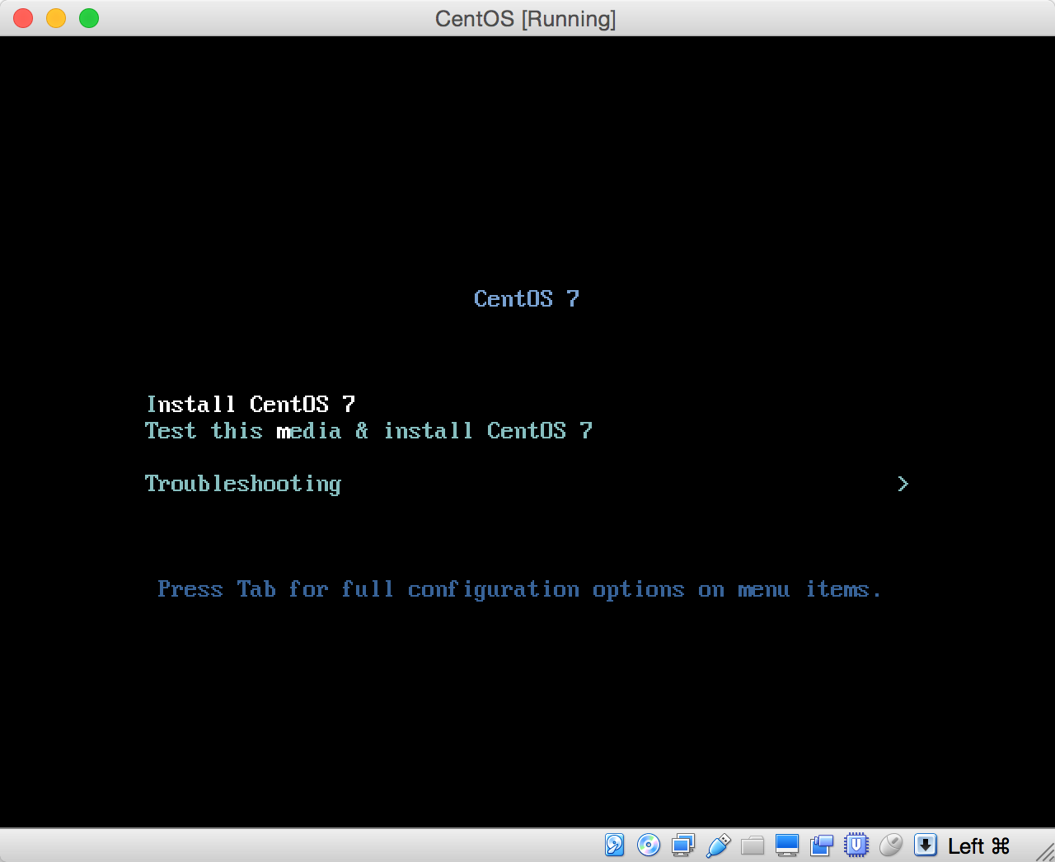

The install process will begin by asking you to select your language of preference. Once you have done that the next prompt will be to select the install destination.

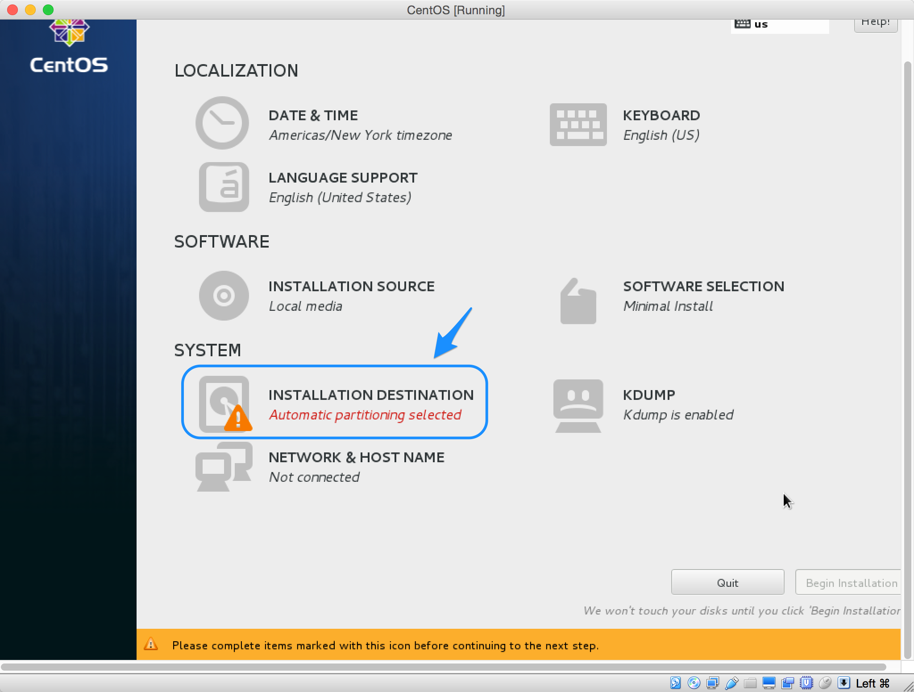

Click on the Install Destination label and then immediately click Done at the top of the next window. Everything in this part of the install wizard has been set for us because of earlier selections we made when setting up the VM space.

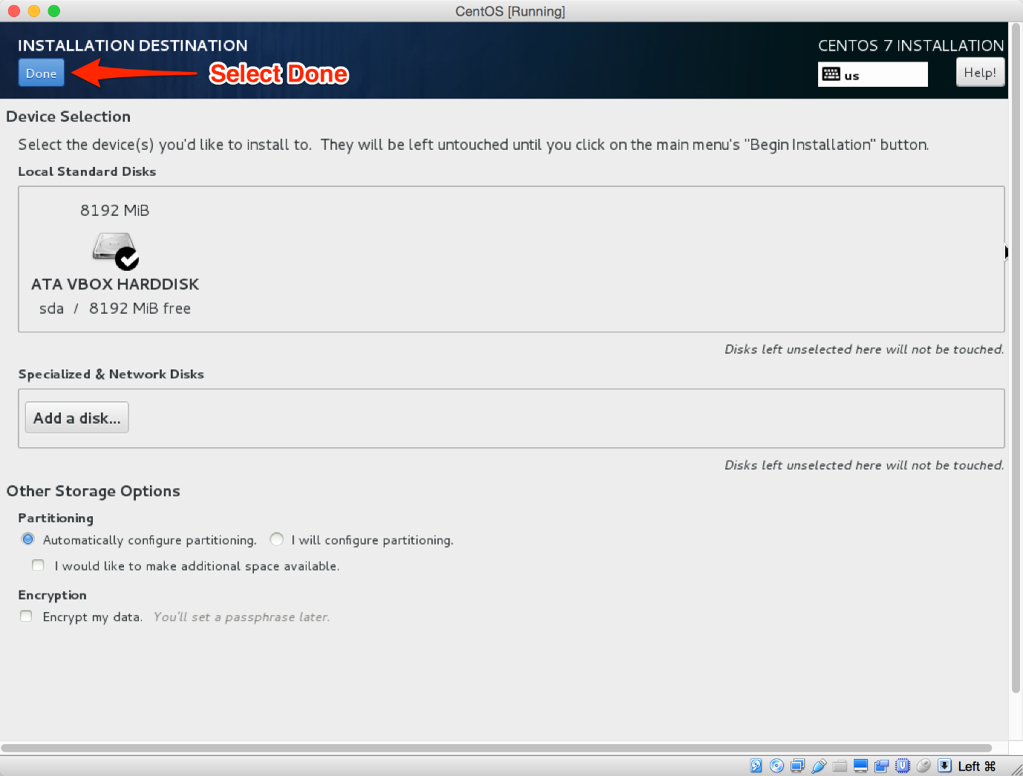

You will now notice that the Install Destination section no longer contains the warning that was previously there. Now you can click on Begin Install.

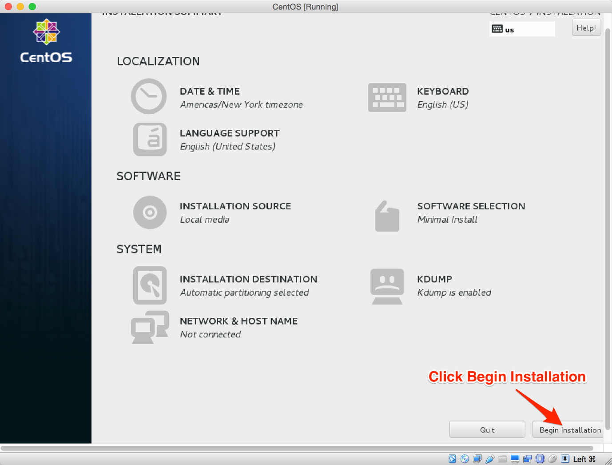

The install will begin, but there are still two more steps we need to take. The next window will give us the opportunity to set the root password and to add an additional account. Lets do both now.

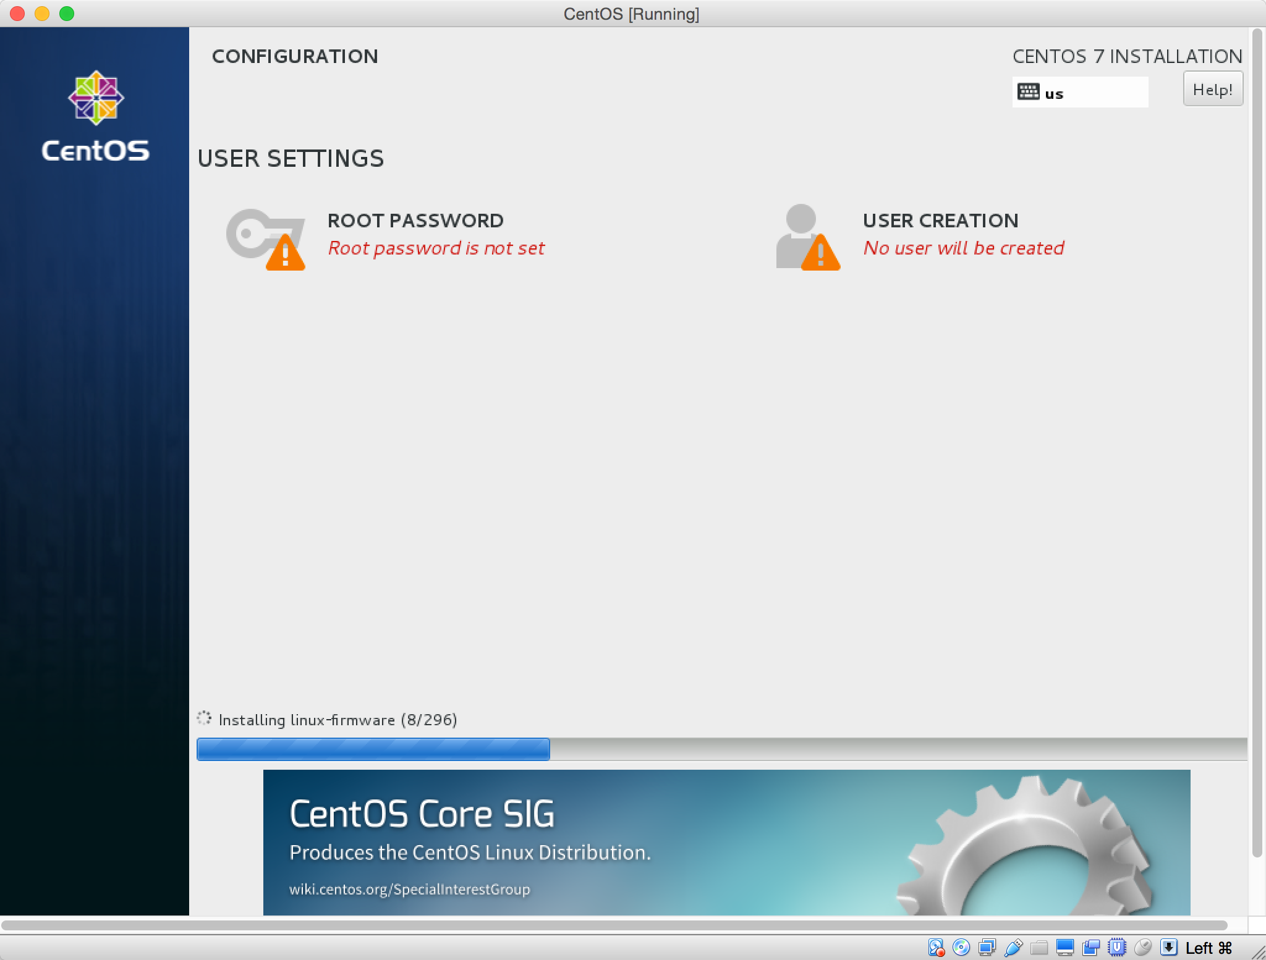

Select Root Password and create a new password for the root account.

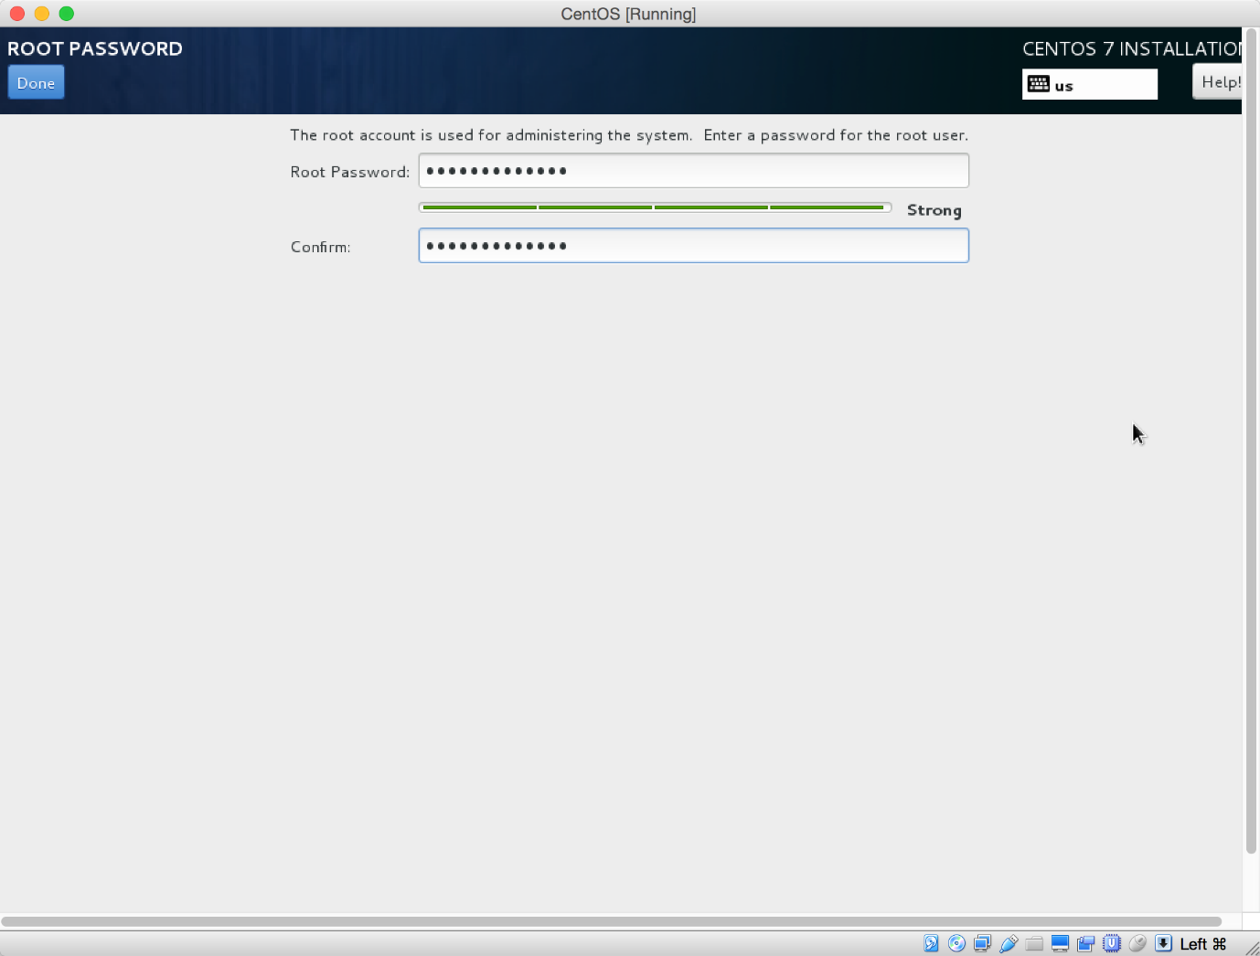

Add another account so that you can log in to the VM without directly logging into root. Go ahead and make the user an administrator.

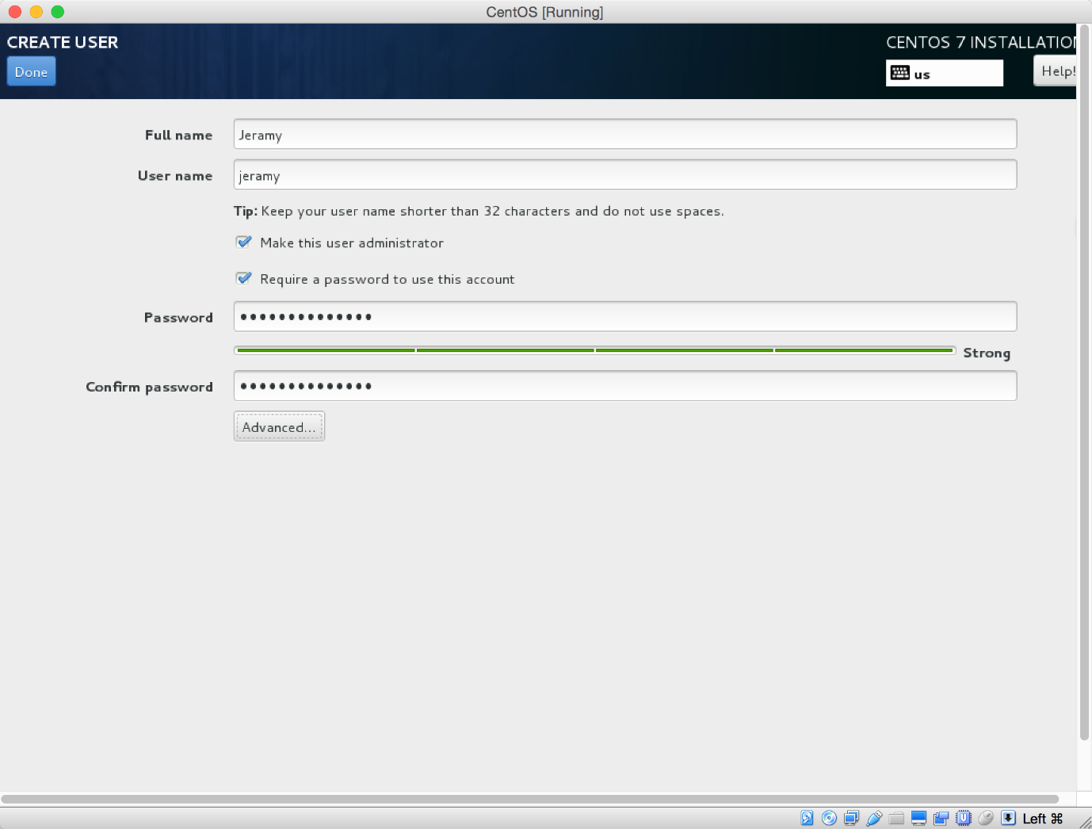

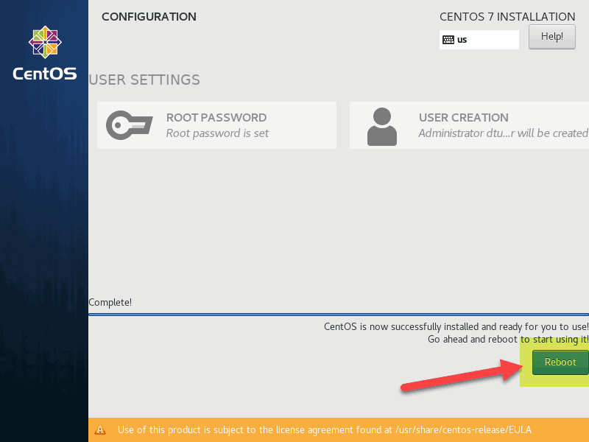

Before you start using your new CentOS installation, reboot the system. Click the **Reboot** button.

Log into the system by using the credentials you defined previously.